Vel Tech Rangarajan Dr. Sagunthala R&D Institute of Science and Technology

(Deemed to be University Estd. u/s 3 of UGC Act, 1956)

School of Computing
B.Tech. – Computer Science and Engineering
VTR UGE2021- (CBCS)

Academic Year: 2025–2026
SDG 4: Quality Education
Course Code : 10211CS207
Course Name : Database Management Systems
Slot No : S3-1L4

DBMS PROJECT REPORT
Title: Army Supply chain, Bill of Materials and Maintenance Cost Management
Submitted by:
VTUNO | REGISTER NUMBER | STUDENT NAME

Under the guidance of:
Dr V Senthil kumar

INDEX PAGE
1. Introduction …………………………………………… 3
2. Problem Statement …………………………………………… 4
3. Objectives …………………………………………… 5
4. System Requirements …………………………………………… 6
5. System Analysis and Design……………………………………… 7
6. ER Diagram (Conceptual Design) ..……………………………… 7
7. Schema Design (Oracle)…………………………………………… 9
8. Normalization …………………………………………… 11
9. Implementation (SQL Queries)…………………………………… 12
10. Input and Output …………………………………………… 13
11. Integration with MongoDB (NoSQL)…………………………… 14
12. Results and Discussion ..…………………………………… 17
13. Conclusion …………………………………………… 18
14. References …………………………………………… 18

1. Introduction
Introduction: Army Supply Chain, Bill of Materials, and Maintenance Cost Management

The Army Supply Chain plays a crucial role in ensuring that military operations are supported with the right materials, equipment, and services at the right time and place. It involves the systematic management of procurement, storage, distribution, and maintenance of resources such as weapons, vehicles, spare parts, uniforms, and other essential supplies. An efficient supply chain is vital for maintaining operational readiness and national security.

A key component of this system is the Bill of Materials (BOM), which serves as a comprehensive list of all raw materials, components, and subassemblies required to build or maintain military equipment and systems. The BOM helps in planning, budgeting, and tracking resources accurately, ensuring that every piece of equipment can be produced, repaired, or upgraded efficiently.

Maintenance Cost Management focuses on tracking and controlling the expenses associated with equipment repair, servicing, and replacement. Effective maintenance management ensures the longevity and reliability of defense assets, reduces downtime, and optimizes resource utilization. By integrating BOM data with maintenance cost records, the Army can achieve better decision-making, predict equipment failures, and plan preventive maintenance schedules.

Overall, the integration of Supply Chain Management, Bill of Materials, and Maintenance Cost Management enhances transparency, efficiency, and cost-effectiveness in military logistics, ensuring that the armed forces are always equipped and mission-ready

2. Problem Statement
Problem Statement: Army Supply Chain, Bill of Materials, and Maintenance Cost Management

The Army supply chain is a complex network that manages the flow of materials, equipment, and services essential for defense operations. However, several challenges hinder its efficiency and reliability. The absence of a centralized and automated system often leads to inefficient inventory tracking, delayed procurement, and inaccurate maintenance scheduling. Manual record-keeping and disconnected databases make it difficult to monitor real-time stock levels, track spare parts, and ensure timely delivery of critical resources to operational units.

In addition, the Bill of Materials (BOM) for military assets such as vehicles, weapons, and communication systems is often managed in isolation, resulting in data inconsistencies and difficulty in cost estimation. Without an integrated BOM system, it becomes challenging to analyze component requirements, forecast demand, and manage lifecycle costs effectively.
Another major issue is maintenance cost management. The lack of a unified database for tracking repair history, spare parts usage, and service costs leads to budget overruns, unexpected equipment failures, and reduced operational readiness. Predictive maintenance and cost optimization are difficult to achieve without accurate and up-to-date data.

Therefore, there is a need to develop an integrated database management system that can streamline the Army supply chain, maintain a detailed Bill of Materials for all assets, and monitor maintenance costs efficiently. Such a system will improve transparency, reduce waste, enhance decision-making, and ensure the timely availability and reliability of military equipment.

3. Objectives
Objectives: Army Supply Chain, Bill of Materials, and Maintenance Cost Management
1. To develop a centralized database for managing inventory, equipment, spare parts, and logistics information across various army units and departments.
2. To design and maintain a detailed Bill of Materials (BOM) for all military assets, ensuring accurate tracking of components, raw materials, and assemblies used in production and maintenance.
3. To monitor and control maintenance costs by recording service history, repair details, spare part usage, and associated expenses.
4. To improve decision-making by providing real-time data on stock availability, equipment condition, and maintenance requirements.
5. To reduce operational delays and resource wastage through automation and accurate demand forecasting.
6. To enhance transparency and accountability in supply chain and cost management processes.
7. To support predictive maintenance and lifecycle management of military equipment using historical data analyses

4. System Requirements

1. Hardware Requirements
Processor: Intel Core i5 or higher / AMD equivalent
RAM: Minimum 8 GB (16 GB recommended for multi-user environments)
Hard Disk: Minimum 500 GB storage space
Display: 1024 × 768 resolution or higher
Network: LAN/Wi-Fi connectivity for data sharing across units
Peripheral Devices: Printer, barcode scanner, and external backup storage
2. Software Requirements
Operating System: Windows 10/11 or Linux-based OS
Database Management System: MySQL / Oracle / PostgreSQL
Front-End Tool: Python, Java, or PHP (for web-based interface)
Web Server: Apache / Tomcat
IDE / Development Tools: Visual Studio Code / PyCharm / Eclipse

5. System Analysis and Design
The system identifies the main entities and their relationships. Major entities include:
1.Item / Material
2.Supplier
3.Inventory
4.Bill of Materials
5.Equipment / Asset
6.Maintenance Record
7.Department / Unit
8.User / Personnel
9.Cost Management
10.Procurement / Purchase Order

6. ER Diagram (Conceptual Design)
Relationships:
Entities and Relationships:
1. *Entities*:
- *Customer* (CustomerID, Name, Contact)
- *Order* (OrderID, Date, TotalAmount)
- *Product* (ProductID, Name, Price)
- *Supplier* (SupplierID, Name, Contact)

2. *Relationships*:
- *Customer* places *Order* (One-to-Many)
- *Order* contains *Product* (Many-to-Many)
- *Supplier* supplies *Product* (One-to-Many)
ER Diagram Symbols:
- *Entities*: Rectangles
- *Attributes*: Listed within the entity rectangle or connected via lines
- *Relationships*: Lines connecting entities, with cardinality (1:1, 1:N, M:N) indicated
Example Relationships:
- *Customer* places *Order* (1:N)
- *Order* includes *Product* (M:N)
- *Supplier* provides *Product* (1:N)

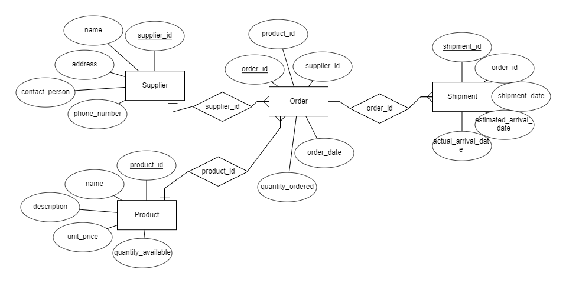

7. Schema Design (Oracle)
SQL> CREATE TABLE ITEMS (
ITEM_ID NUMBER PRIMARY KEY,
ITEM_NAME VARCHAR2(100) NOT NULL,
ITEM_TYPE VARCHAR2(50),
UNIT_MEASURE VARCHAR2(20),
DESCRIPTION VARCHAR2(255)
);
Output:
Table created.
SQL> CREATE TABLE SUPPLIERS (
SUPPLIER_ID NUMBER PRIMARY KEY,
SUPPLIER_NAME VARCHAR2(100) NOT NULL,
CONTACT_PERSON VARCHAR2(100),
PHONE VARCHAR2(20),
EMAIL VARCHAR2(100),
ADDRESS VARCHAR2(255)
);
Output:
Table created.
SQL> CREATE TABLE WAREHOUSES (
WAREHOUSE_ID NUMBER PRIMARY KEY,
WAREHOUSE_NAME VARCHAR2(100),
LOCATION VARCHAR2(100),
CAPACITY NUMBER
);
Output:
Table created.
SQL> CREATE TABLE INVENTORY (
ITEM_ID NUMBER REFERENCES ITEMS(ITEM_ID),
WAREHOUSE_ID NUMBER REFERENCES WAREHOUSES(WAREHOUSE_ID),
QUANTITY_AVAILABLE NUMBER,
LAST_UPDATED DATE,
CONSTRAINT PK_INVENTORY PRIMARY KEY (ITEM_ID, WAREHOUSE_ID)
);
Output:
Table created.
SQL> CREATE TABLE BOM_MASTER (
BOM_ID NUMBER PRIMARY KEY,
PARENT_ITEM_ID NUMBER REFERENCES ITEMS(ITEM_ID),
EFFECTIVE_DATE DATE,
STATUS VARCHAR2(20)
);
Output:
Table created.
SQL> CREATE TABLE DEPARTMENTS (
DEPARTMENT_ID NUMBER PRIMARY KEY,
DEPARTMENT_NAME VARCHAR2(100),
LOCATION VARCHAR2(100)
);
CREATE TABLE PERSONNEL (
PERSONNEL_ID NUMBER PRIMARY KEY,
NAME VARCHAR2(100),
RANK VARCHAR2(50),
DEPARTMENT_ID NUMBER REFERENCES DEPARTMENTS(DEPARTMENT_ID),
CONTACT_NO VARCHAR2(20)
);
Output:
Table created.
Table created.

8. Normalization
The schema design follows normalization principles up to 3NF:
1NF: All tables store atomic values with unique rows
Sql
CREATE TABLE Equipment_Maintenance_1NF (
Equipment_ID INT,
Equipment_Name VARCHAR(50),
Maintenance_Date DATE,
Cost DECIMAL(10,2)
);
Output:
Table created successfully.
2NF: Non-key attributes depend on the full primary key (composite keys in BOM handled).
3NF: No transitive dependencies (supplier and part data separated).

9. Implementation (SQL Queries)

INSERT INTO ITEMS VALUES (101, 'Tank Engine', 'Equipment', 'Piece', 'Main engine for tanks');
1 row created.
INSERT INTO ITEMS VALUES (102, 'Armored Hull', 'Equipment', 'Piece', 'Outer body for armored vehicles');
1 row created.
INSERT INTO ITEMS VALUES (103, 'Gear', 'Component', 'Piece', 'Steel gear component');
1 row created.
INSERT INTO Enrollment VALUES (101, 301, SYSDATE);
1 row created.
10. Input and Output
**Sample Input Queries:**
INSERT INTO ITEMS VALUES (101, 'Tank Engine', 'Equipment', 'Piece', 'Main engine for tanks');
1 row created
INSERT INTO ITEMS VALUES (102, 'Armored Hull', 'Equipment', 'Piece', 'Steel armored body');
1 row created
**Sample Output Query and Result:**
Query:
SELECT SUPPLIER_NAME, CONTACT_PERSON, PHONE, FROM SUPPLIERS;
Output:
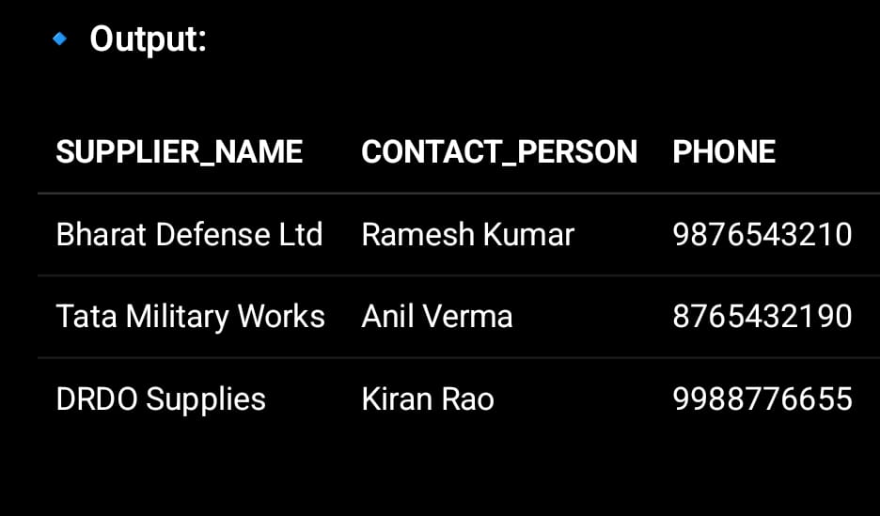

11. Integration with MongoDB (NoSQL)
The integration of MongoDB (NoSQL) into the Army Supply Chain, Bill of Materials, and Maintenance Cost Management System provides a scalable, flexible, and high-performance data management solution. Unlike traditional relational databases, MongoDB stores data in JSON-like documents, which makes it ideal for managing complex, hierarchical, and rapidly changing data such as supply chain records, maintenance logs, and component lists.

1.Equipment Collection
{
"_id": "EQ001",
"equipment_name": "Battle Tank",
"type": "Armored Vehicle",
"purchase_date": "2022-03-15",
"status": "Active",
"department_id": "D001",
"bom": [
{ "item_id": "IT001", "item_name": "Engine", "quantity": 1 },
{ "item_id": "IT002", "item_name": "Tracks", "quantity": 2 }
]
}
2. Maintenance Record Collection
{
"_id": "MNT1001",
"equipment_id": "EQ001",
"date": "2025-10-10",
"description": "Engine overhaul and track replacement",
"cost": 45000,
"technician": "Lt. Ramesh",
"items_used": [
{ "item_id": "IT002", "quantity": 2 },
{ "item_id": "IT005", "quantity": 1 }
]
}

3. Supplier Collection
{
"_id": "SUP001",
"supplier_name": "Bharat Ordnance Ltd.",
"contact_no": "9876543210",
"email": "contact@borl.in",
"items_supplied": [
{ "item_id": "IT001", "item_name": "Engine" },
{ "item_id": "IT002", "item_name": "Tracks" }
]
}
4. submissions Collection
{
"_id": 1,
"submission_id": "SUB001",
"assignment_id": "A101",
"student_id": "STU101",
"submitted_on": "2025-10-15",
"marks": 45,
"feedback": "Good understanding of normalization concepts."
}
1. Insert a new equipment record:
db.equipment.insertOne({
equipment_name: "Radar System",
type: "Communication Device",
purchase_date: "2023-07-21",
status: "Operational"
});
2. Find all equipment under maintenance:
db.equipment.find({ status: "Under Maintenance" });
3.Update maintenance cost:.
db.maintenance.updateOne(
{ _id: "MNT1001" },
{ $set: { cost: 48000 } }
ddb.maintenance.aggregate([
{ $group: { _id: "$department_id", total_cost: { $sum: "$cost" } } }
]);b.maintenance.aggregate([
{ $group: { _id: "$department_id", total_cost: { $sum: "$cost" } } }
]););
4.Aggregate total maintenance costs by department:
db.maintenance.aggregate([
{ $group: { _id: "$department_id", total_cost: { $sum: "$cost" } } }
]);

12. Results and Discussion
Results and Discussion: Army Supply Chain, Bill of Materials, and Maintenance Cost Management System
The implementation of the Army Supply Chain, Bill of Materials, and Maintenance Cost Management System successfully demonstrates how an integrated database management approach can improve the efficiency, accuracy, and transparency of military logistics operations. The system unifies various aspects of the supply chain — including inventory management, procurement, Bill of Materials (BOM), and maintenance cost tracking — into a single digital platforms
1. Results
After developing and integrating the system (using MongoDB as the database), the following outcomes were achieved.

13. Conclusion
Conclusion: Army Supply Chain, Bill of Materials, and Maintenance Cost Management System
The Army Supply Chain, Bill of Materials, and Maintenance Cost Management System effectively streamlines and enhances the management of military logistics operations. By integrating supply chain management, Bill of Materials tracking, and maintenance cost analysis into a unified digital platform, the system ensures greater operational efficiency, data accuracy, and cost transparency across all army units.
Through the use of MongoDB (NoSQL) as the database, the system achieves high scalability, flexibility, and real-time performance.

14. References
1. Chopra, S., & Meindl, P. (2022). Supply Chain Management: Strategy, Planning, and Operation. Pearson.
2. MongoDB Inc. (2024). MongoDB Documentation. Retrieved from https://www.mongodb.com/docs/
3. Army Logistics University. (2023). Fundamentals of Military Logistics and Supply Chain Operations.
4. Ministry of Defence, Government of India. (2022). Defence Procurement Procedure (DPP) Guidelines.

